

SCHOOL OF COMPUTER SCIENCE AND ENGINEERING

**BACHEL0R OF COMPUTER SCIENCE AND ENGINEERING**

“INTERNET PROGRAMMING LABORATORY”

COURSE CODE: CSE326

**TOPIC:**

**ELECTRICITY WEBSITE**

SUBMITTED BY:

NAME ROLL NO. REG. NO.

Aryan Sharma 37 11906275

Mohd. Asif Sheikh 38 11906281

Aman Rana 39 11906306

SUBMITTED TO:

Moin Hasan

Professor, Lovely Professional University

**REPORT FOR PROJECT**

* **INTRODUCTION:**

Our website is a project which aims in developing a computerized system to provide the information about the electricity board. It is very difficult for a user to gain knowledge by visiting offices again and again and it is also difficult for electricity board to make their offices in each and every state. Therefore, to give you ease we are providing a computerized backend.

Through this site you can get to know about different responsibilities, mission, vision and innovations of electricity board.

* **PROPOSED METHODOLOGY**
* First, we decided to make the linking webpages which will be later on linked to the home page.
* Then the linking webpages were made using references from a few websites.
* Then a single font and design was applied to the webpages by multiple CSS files.
* Then all the webpages were linked to the home page.
* In the end, images and transitions were added to make the website more presentable and livelier.
* **LITERATURE REVIEW :**
* HOME PAGE:

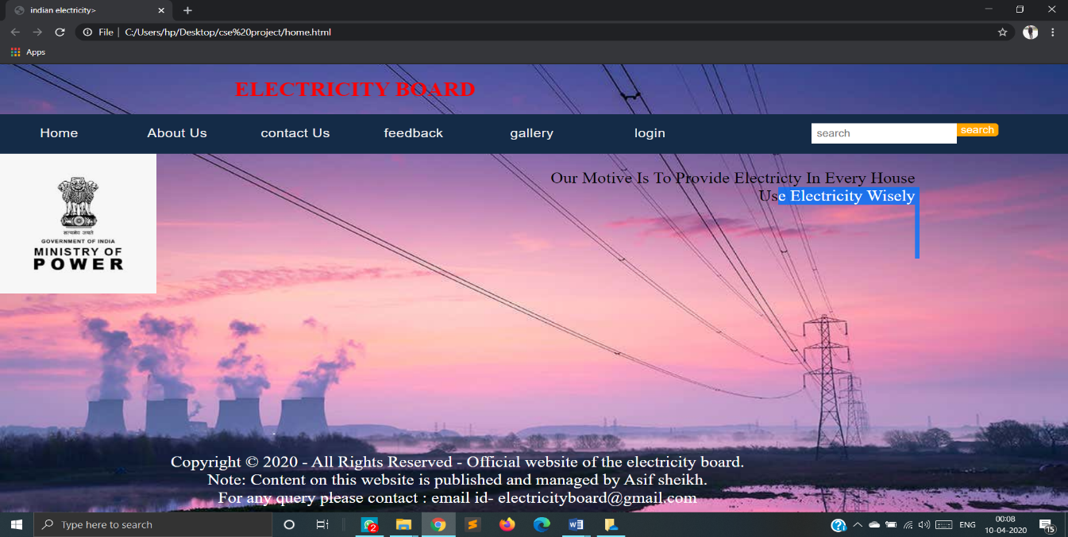This HOME PAGE contain other links of our website like- About us, contact us and the login page.

This page have an easy access to our galley and also contain contact information.

So user can easily access all the link from one page.

Now we have another page linked with home page

* About us:

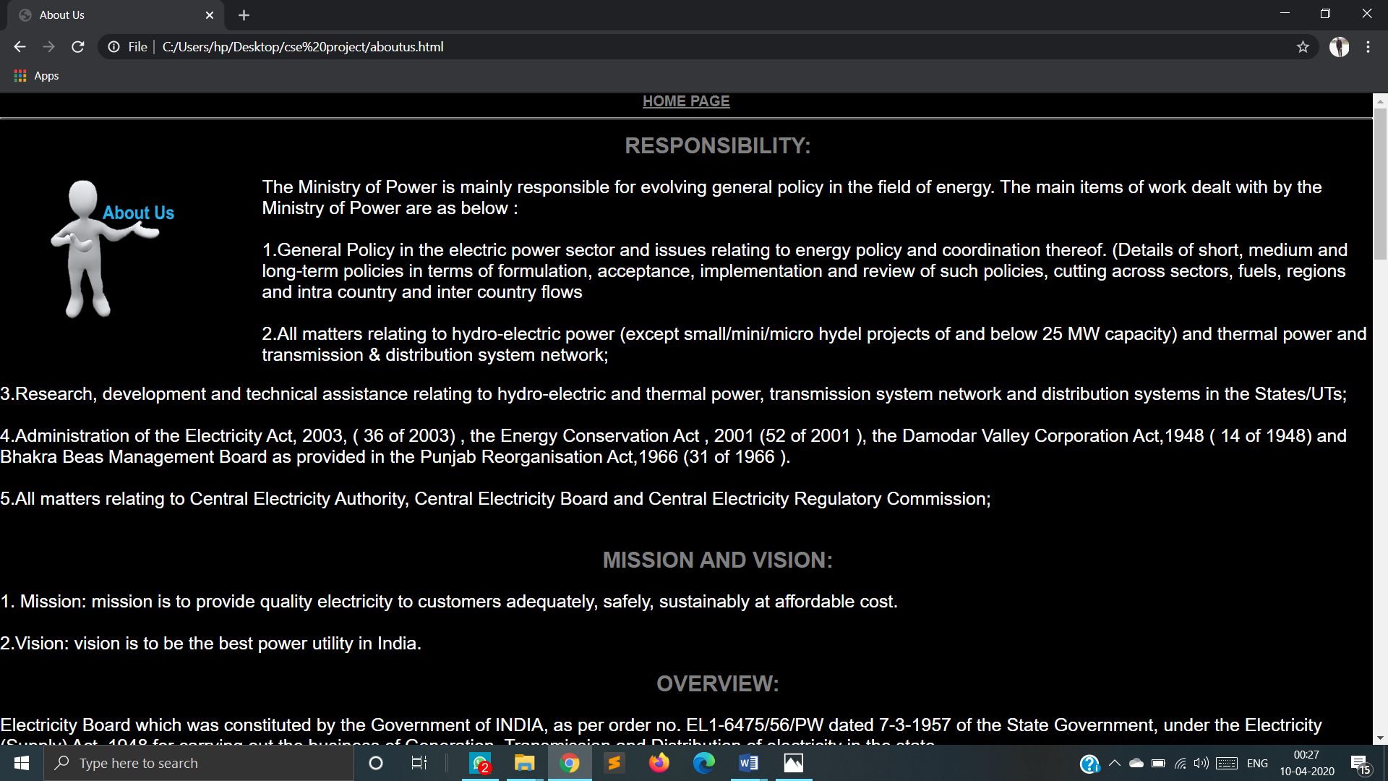

In this page user can get to know about the responsibilities of electricity board. In the top, a quick access to home page is also available. 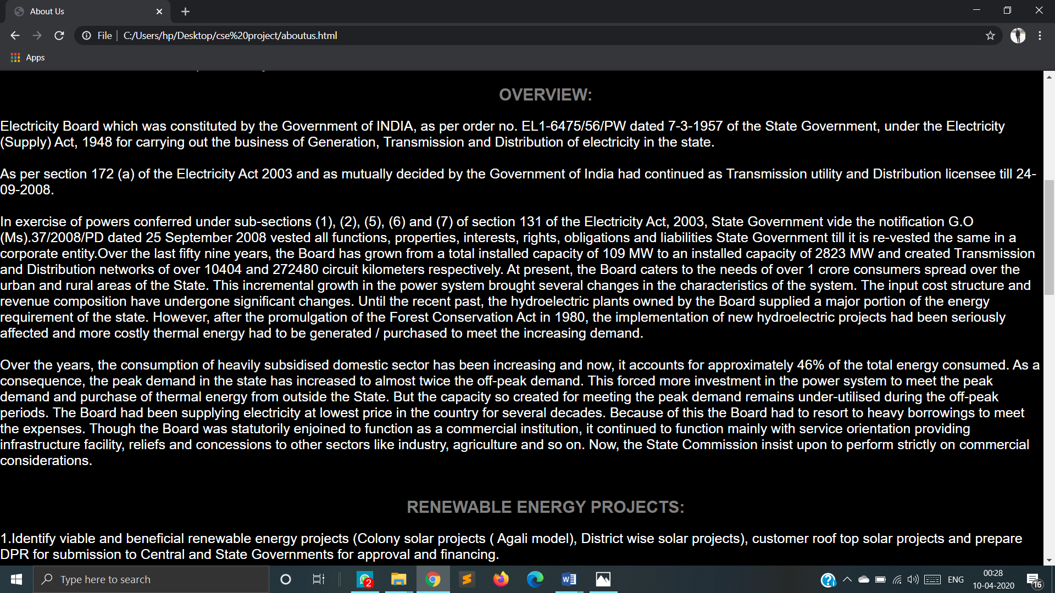

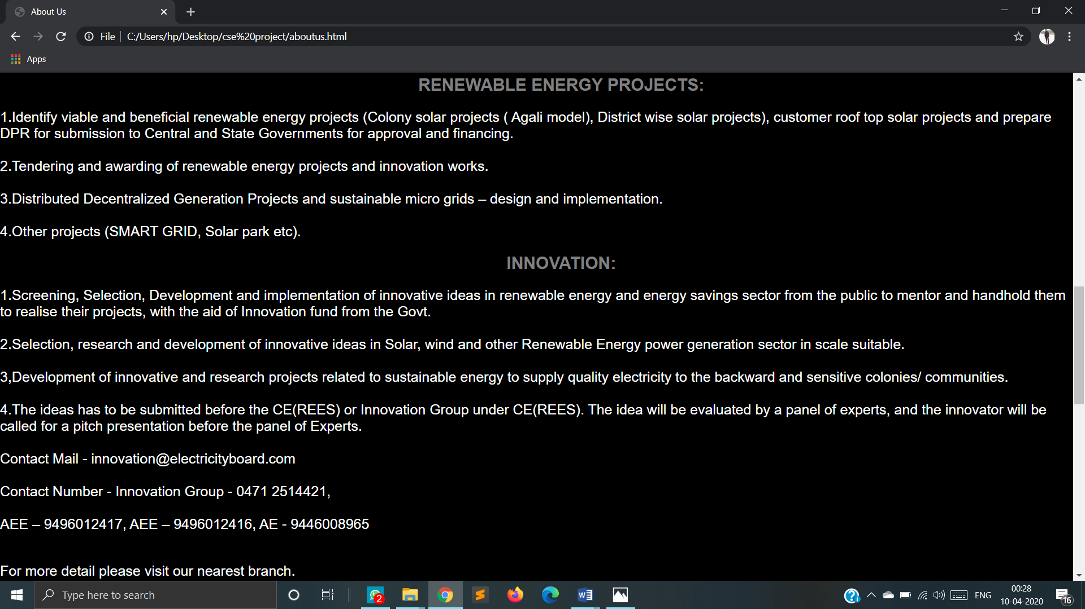And on the other hand this page tells us about the mission, vision and overview of the electricity board with Our new, running and renewable energy projects are posted here,

And user can also send their innovative ideas through this page in the innovation section.

In innovation section there is a link named as CONTACT US.

And there is an another link for the HOME PAGE named as ELECTRICITY BOARD.

Also you can find the information about the creators of this website

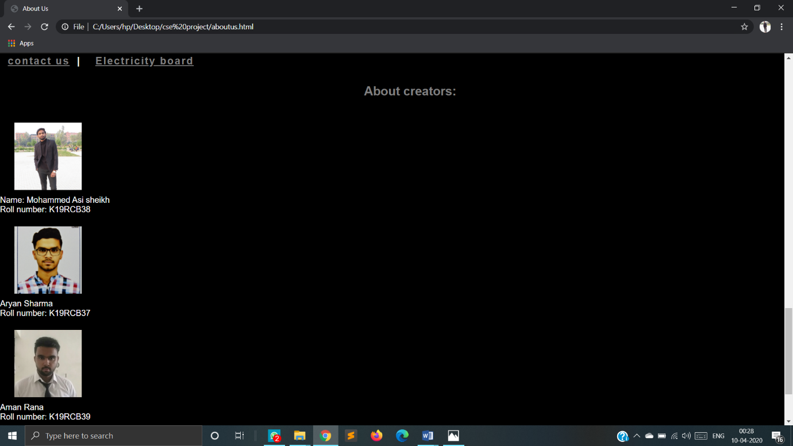

Now we another page CONTACT US

* CONTACT US:

In this page user can directly contact to the electricity board

And convey their problems and give their innovative ideas to

Make website more useful to user.

In this contact page we have two external links one for the

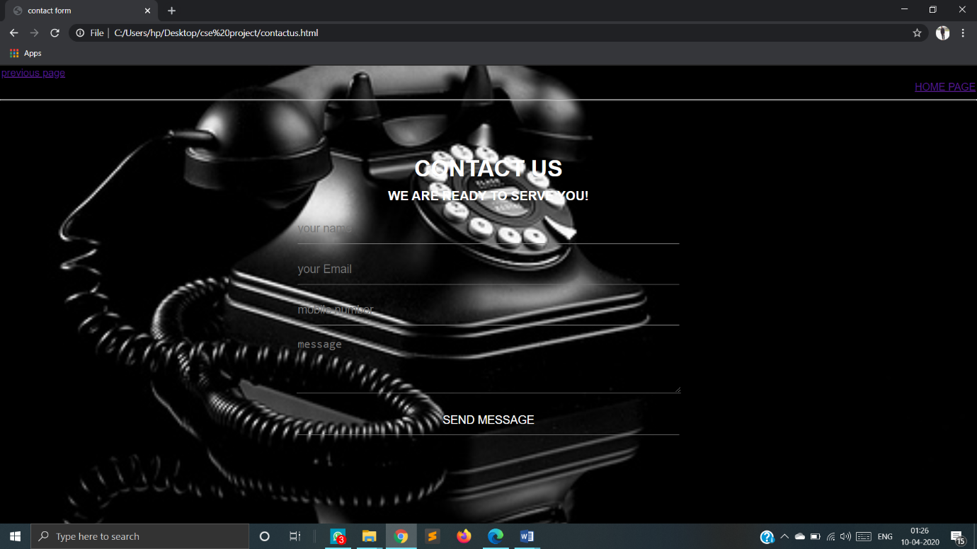

Previous page and one for the HOME PAGE named as previous page and home page respectively.

Now we have next page as our FEEDBACK PAGE

* FEEDBACK:

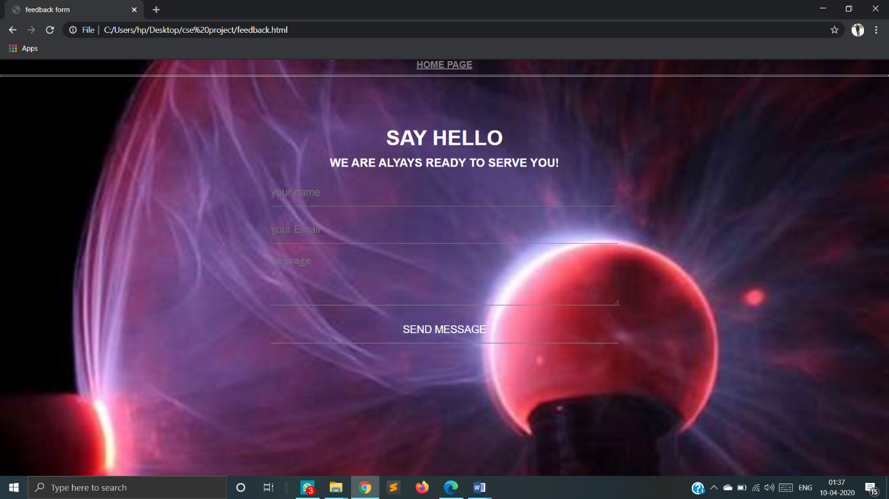On the top of the page we have a easy access of HOME PAGE.

By this feedback page user can easily comment on the staff member and their working and their attitude towards user.

Now we have some memories and working field pictures to show our users

So here is a page in which all the pictures are added

Named GALLERY

* 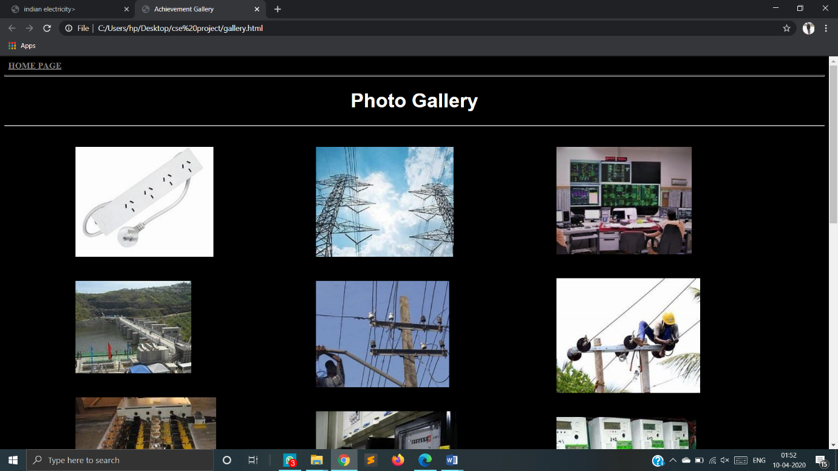GALLERY:

Last but not least we have a LOGIN PAGE for users.

* LOGIN:

By this page user can log in to their account and check their data which can be handled by the electricity board.

For which user have a specific user id and password to log in their account

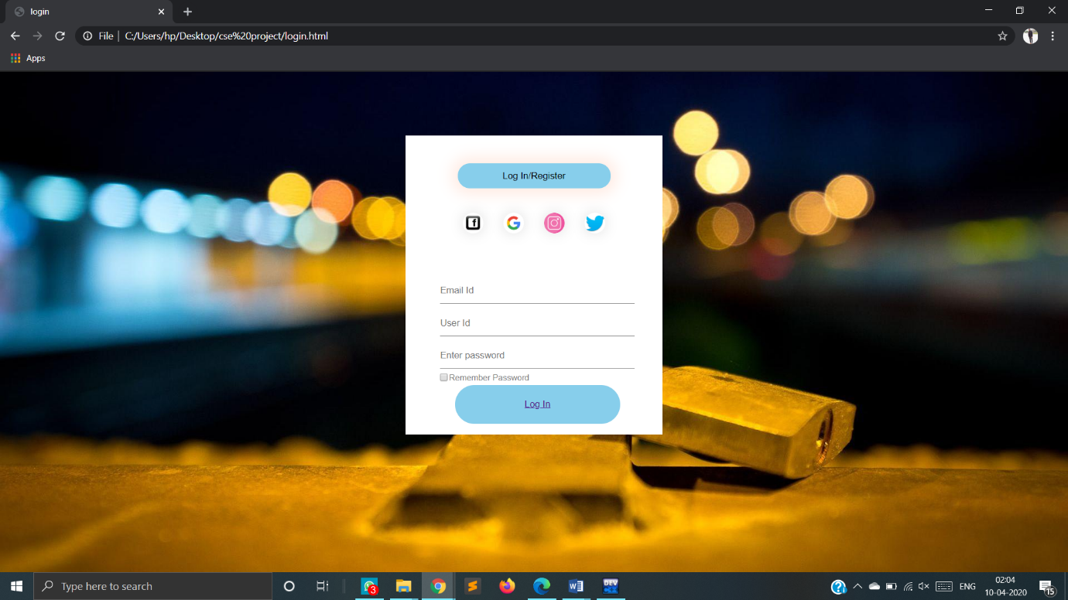

* **REFERENCES:**

The following are the websites which were used as a

Reference for the making of the project:

<http://www.kseb.in/index.php?lang=en>

<https://www.goaelectricity.gov.in/>

<https://powermin.nic.in/>

* **PLAGIRISM:**

We have put lot of effort to make our project genuine and Authentic. In this process we have tried to keep each facts and information on our website real and eventually we have relied upon content from some of the popular websites for various section such as gym related insights. The contents which are influenced by the popular websites and name of websites are listed as-:

* About Us-:

To give customers more insight into who is involved with our business and exactly what we do we have taken reference for this section from one of the highly popular website of Kerala board of electricity.

* Gallery-:

To feature some astounding pictures in our gallery section to make it livelier we relied upon electricity website of goa and Powermin (Indian website if energy and electricity).

* **RESULT AND DISCUSSION:**

The present system is totally depending on manual data management for different activities such as maintaining details of customer, supplier etc. They maintain different registers for various activities such as storing and searching data .In present system all transactions are done manually with pen and paper so the frequent updating is not possible. Also generating report ,bills accurately is not possible with current system .

In short system is lacking facilities such as searching, adding data efficiently and effectively.

* **CONCLUSION:**

Our System allows the user to store the employee details, the details of person who in the electricity board. This software package allows storing the details of all the data related to electricity and department of electricity. The system is strong enough to with stand regressive yearly operations under condition where the database is maintained and cleared over a certain time of span. The implementation of the system in the organization will considerably reduce date entry, time and also provide readily calculated reports.